CS4640 A<1r>

<Yingjie Lian>

August 21, 2019

**Question 1 Answer:** I have done Chapters 1 and 2 exercises.

**Question 2 Answer:**

For this question, I have used these commands: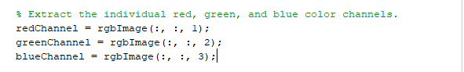

To find different segment of red, green, and blue of map1.jpg. Then, I have generated the useful color histogram below:

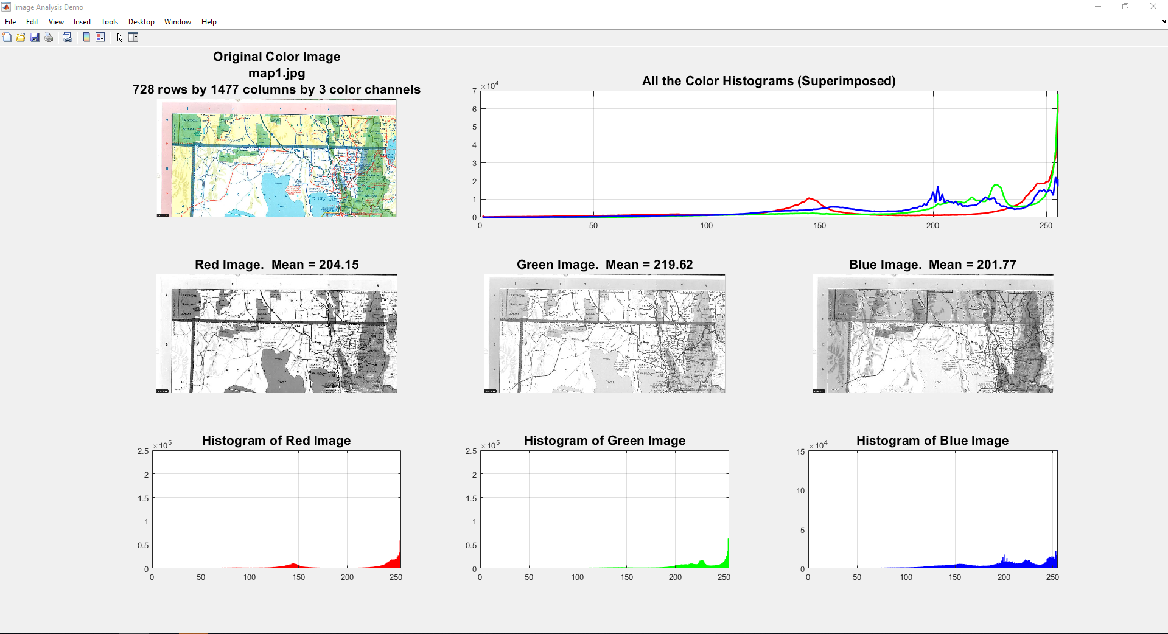

As we can see, in the Red Image, the water bodies and forests are more obvious because they are in blue and green.

In the Green Image, the red roads and state border lines are more obvious because they are in red and blue.

In the Blue Image, the red roads and forests are more obvious because they are in green and red.

Then I have used the given .m file CS4640_truth.m and combo.m.

Then I have got these three images which represents water areas, forest areas, and railways:

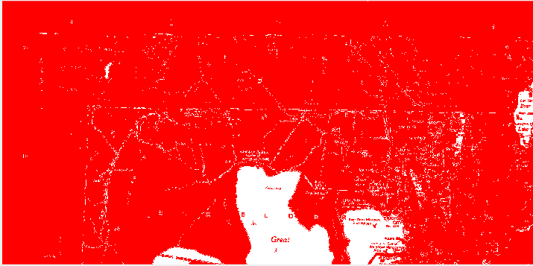

(White part is water)

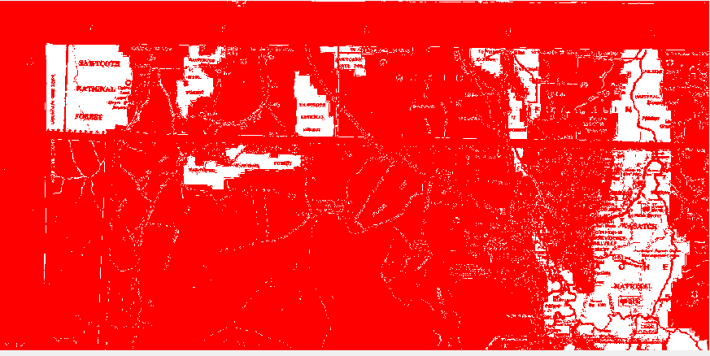

(White part is forest)

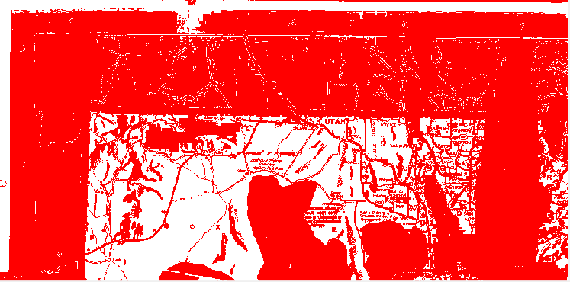

(The red lines are railways, white parts are the land)

For the railway part, here are my codes:

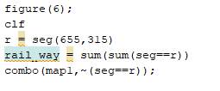

I used r store the railway segments.

Here are the commands and variables I have used for doing imapprox() function: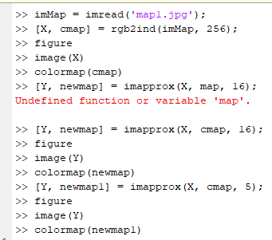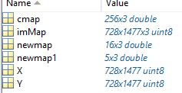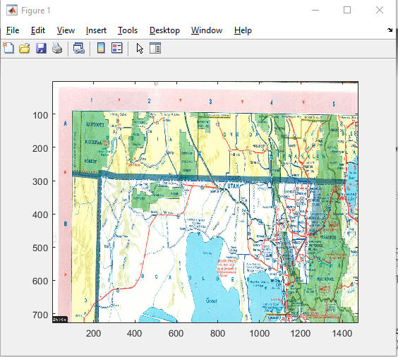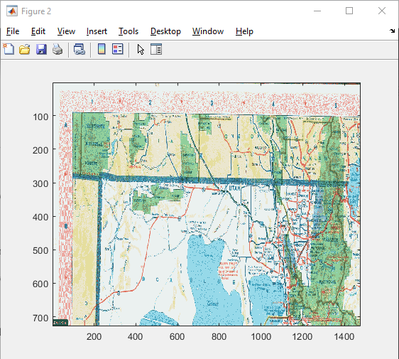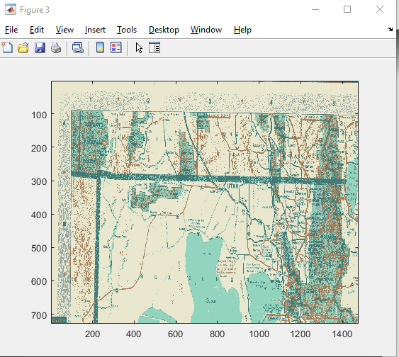

Figure 1 is the original image which has 256 colors;

Figure 2 has been reduced the number of colors in the indexed image from 256 to only 16 colors;

Figure 3 has been reduced the number of colors in the indexed image from 256 to only 5 colors.

As we can see, figure 2 got some **picture distortion** because of reducing the number of colors; figure 3 is even worse if we compare to figure 1.

**Q2(A1-Redo)**

I really don’t know how to use impprox() to get the segement areas, but I figured out by using my getcolor.m, here are the codes:

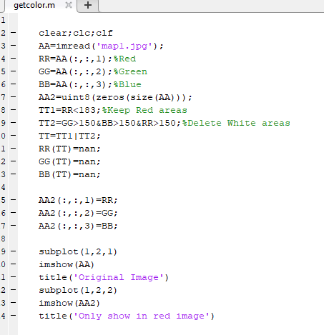

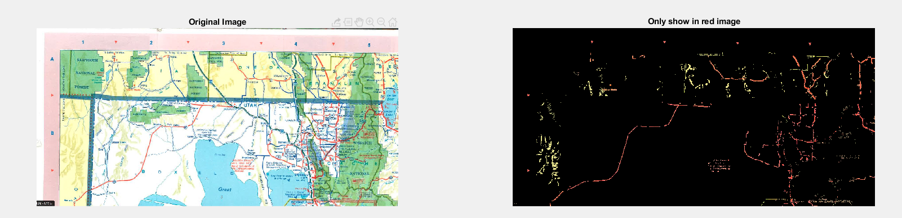

The above image shows only has red railways area.

Then I have changed this code to only show what’s in green and blue:

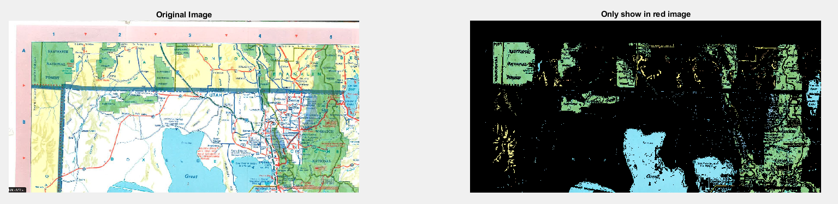The above image shows only has green forest and blue water areas.

**Question 3 Answer:**

APPROACH#1:

Here are the commands that I used for this questions:

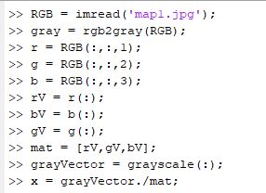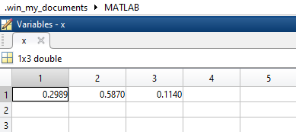

Then we got the index for alpha, beta, gamma which are the same that we had from the textbook.

Thus, the hypothesis that rgb2gray uses the function given in the book has been proven when α=0.2989 β = 0.5870 γ = 0.1140.

**Q3(A1-Redo)**

I have created a function called getIndex.m, here are my codes:

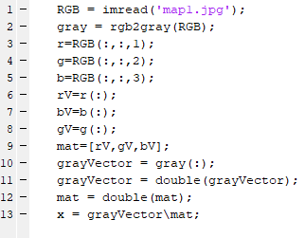

After running this code, I have got the x:

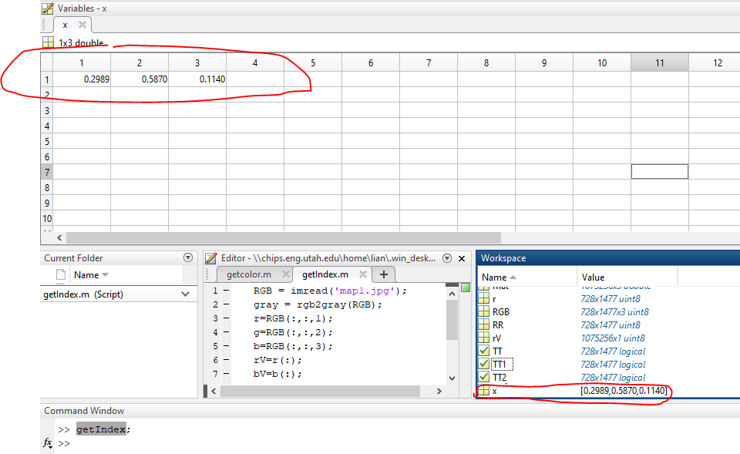Then we got the index for alpha, beta, gamma which are the same that we had from the textbook.

Thus, the hypothesis that rgb2gray uses the function given in the book has been proven when α=0.2989 β = 0.5870 γ = 0.1140.

APPROACH#2:

Here are the commands that I used for this questions: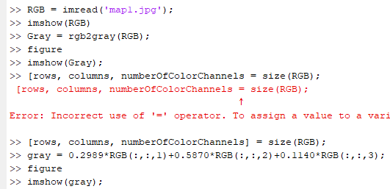

And here are the figures that I got:

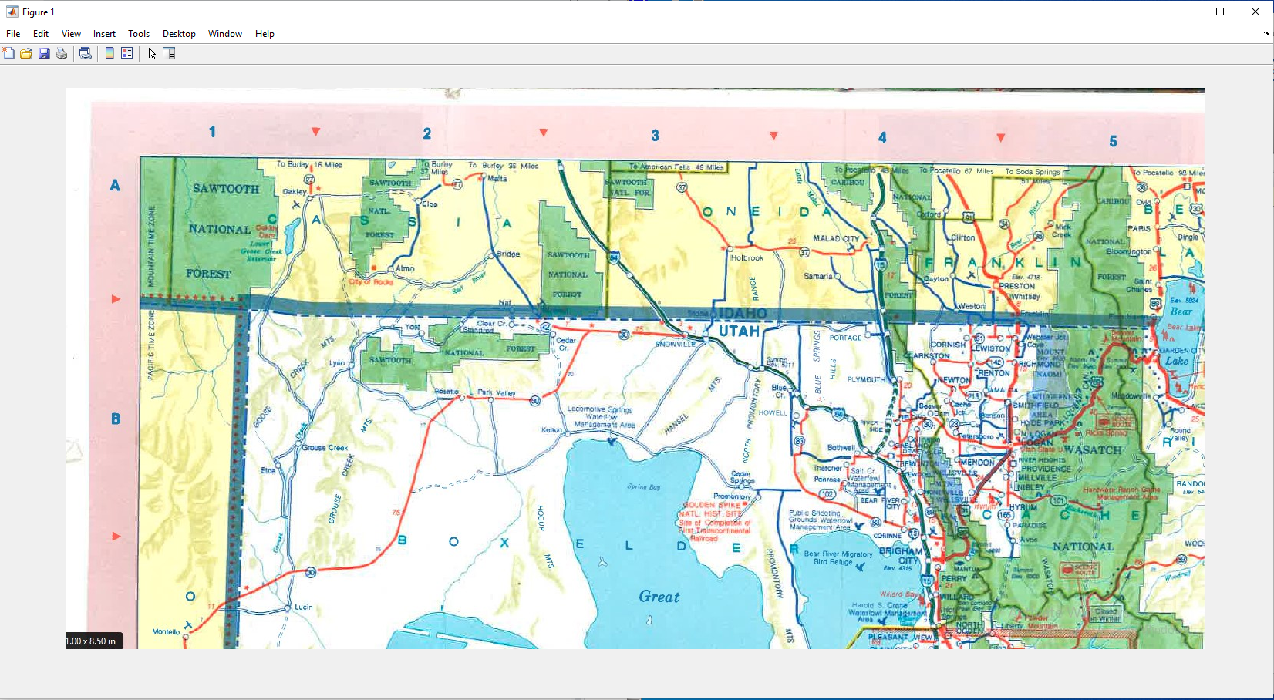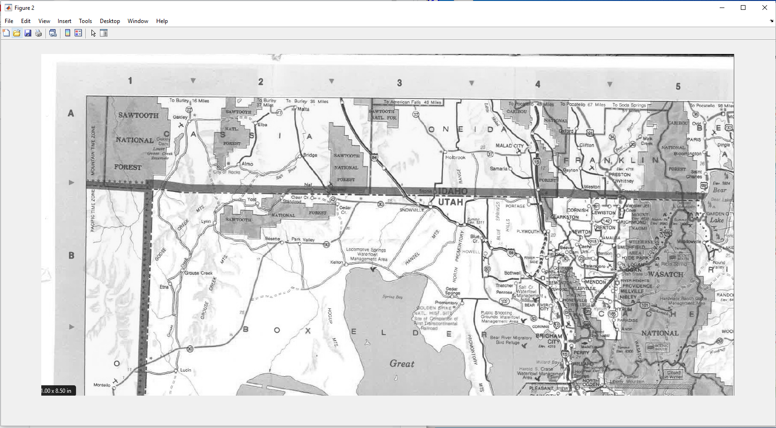

(Figure1) (Figure2)

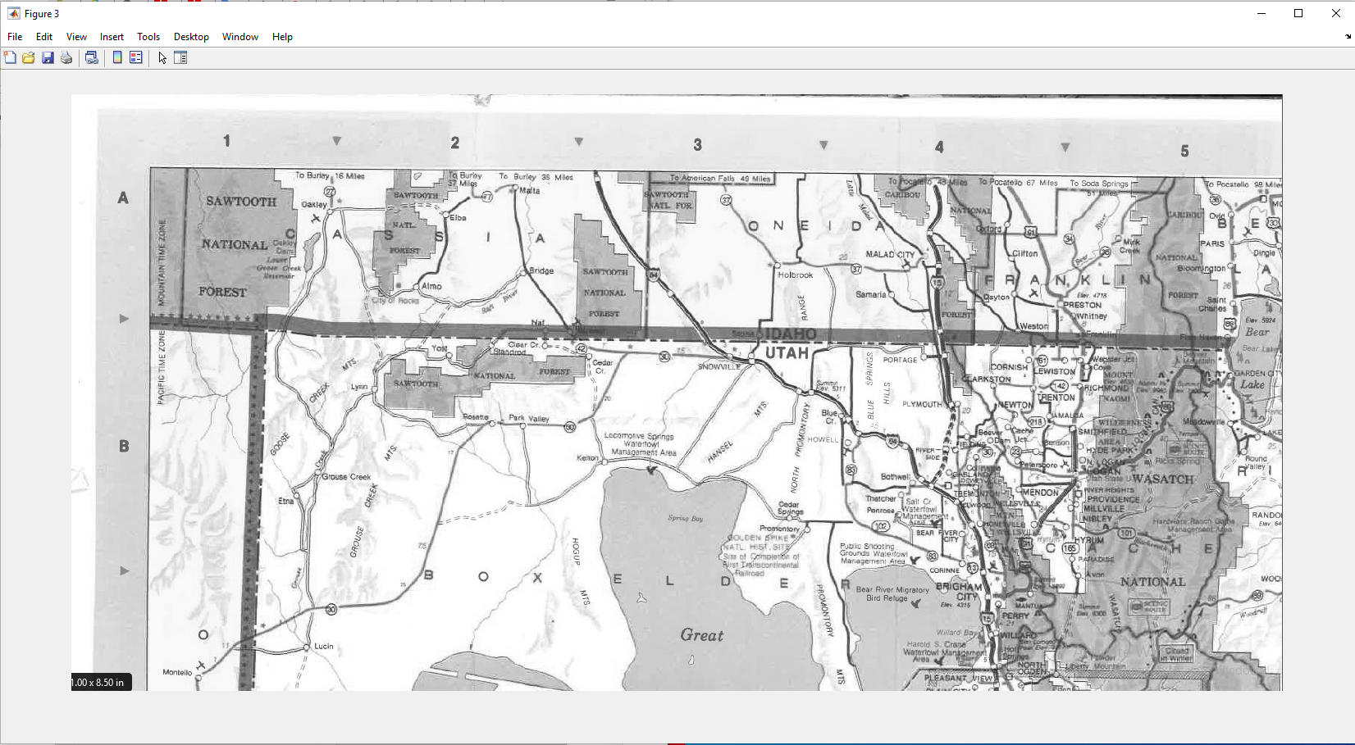

(Figure3)

Here is what I have tried:

First, I used imread() to get the RGB image figure1.

Then, I used rbg2gray() to convert the RGB image to Gray-scale image which is figure2.

Finally, I have used the index that provided in textbook Page 12. which is the standard NTSC conversion formula to convert the RGB image to another image which is figure3.

If we compare figure2 and figure3, we will see that figure3 is also a Gray-scaled image.

Thus, the hypothesis that rgb2gray uses the function given in the book has been proven when α=0.2989 β = 0.5870 γ = 0.1140.

**Question 4 Answer:**

**Q4(A1-Redo)**

For this question, I have used this equation to get my x and y points from X, Y, Z 3D points

Since x and y is a set of points, we can find the min and max value, in order to map it along with the M and N.

After that, I have used linspace to match x_min, x_max, y_min, y_max with N and M.

Last, use fspecial() function apply for the filter, then get the image.

2. For each problem number in the assignment, have a header

with brief problem description; e.g.:

1. Segmenting Semantic Regions

3. For each problem, give the your own answer; if you are asked to explore

a topic (e.g., correlation), then describe what you understood the major

issues to be and how you looked into them, and what you found out. The

discussion whould be corroborated by data (images, plots, etc.). You

should also discuss if and how this technique might be useful in document

analysis.

4. Describe the solution and how it is implemented, including any algorithms

developed (provide as high-level pseudo-code). Be sure to discuss any

important features of your solution.

5. Use handin to submit the report PDF and all Matlab functions necessary

to execute.